2018 Sem 1 GP MH AC Recall (Partial recall)

MCQ
- X ray image of Neck of femur fracture
- Tardive dyskinesia, Astasia-abasia
- OCPD
- Mental Health Act
- SSRI
- Clozapine side effect
- Social phobia CBT
- GP – a baby with eczema. Which steroid cream? (e.g. mometasone)

SAQ
General Practice
- Jack is a 3yo child who is brought into the Victorian Aboriginal clinic by his mother. The mother reports that Jack has had a sore throat and fever for the past few days but now is complaining of ear pain on the left side.
A physical examination is conducted on Jack. The findings were the R) ear was normal whilst the L) ear appeared as below on otoscopy.

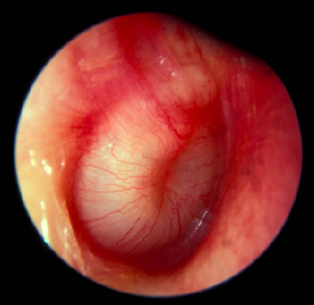

- Describe 4 features that can be seen via the otoscope (4 marks)
- Name the 4 most likely pathogens to have caused Jack’s condition (4 marks)
- Should Jack be treated with antibiotics? Justify your answer (1 mark)

2 weeks later Jack’s ear pain has resolved however his mother has brought him in as she is concerned about his constipation. She reports that he does not go frequently and when he does he produced ‘rabbit like poo’ as well as complaining that it is painful to defecate.
- Name 5 red flags you will need to rule out on history (5 marks)
- Name 6 management steps you would advise Jack’s mother in regards to the constipation (6 marks)

- 57yo male comes into GP complaining of dyspnoea. He recently noticed worsening of dyspnoea with exertion, whilst gardening. The shortness of breath is associated with a mild cough. The patient infrequently visits the GP.
Past Mx:
- Diabetes (T2DM)
- Bowel cancer

Medications
- Perindopril
- Atorvastatin
- Metformin
- Gliclazide
Social history
- Drinks 3 standard drinks a day
- Smoker
Examination
- Hypertensive

- List 3 important differential diagnoses to consider (3 marks)

Here is his CXR
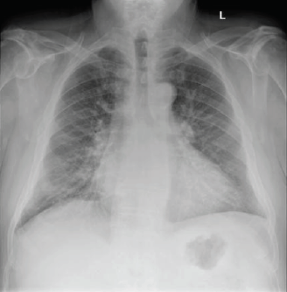
- Name one finding and describe the feature on CXR (2 marks)
- List 5 investigations to be performed for this presentation and for each one, give one rationale of why (5 marks)
- Given his clinical picture and CXR, what is the likely cause? (1 mark)
- Outline 3 non-pharmacological management strategies (3 marks)
- What are 2 first-line pharmacological options and list 2 side effects of each (6 marks)

Mental Health
- 56 year old man from Poland, lives alone, divorced 7 years ago, brought in with supportive daughter. Recent workplace injury involving his dominant arm, rendering him unable to work. Refuses welfare payments, living off his savings. Poor attendance to hand therapy, and when he does the hand therapist reports patient smelling of alcohol. Daughter has been regularly visiting him over the past 2 weeks and states he has been drinking alcohol during the day. Patient denies anything is wrong with him and that the daughter is taking too much interest. Daughter states all men in their family are like this. You and the daughter agree that he has no significant past medical history or psychiatric history and his physical examination is unremarkable.

The psychiatrist believes this patient has major depressive disorder.
- List 2 differential diagnoses other than major depressive disorder (2 marks)
- Provide a formulation using the biopsychosocial model - include two points for each element (8 marks)
- What are the differences in mechanism of action / efficacy or safety / addictive potential between sertraline and diazepam (6 marks)

The patient refuses to take medication due to his beliefs.

- What are 2 psychological 2 social management strategies? (4 marks)

- 28 year old mother of 2 children and primary school teacher is brought in by her caring mother. The patient has panic disorder and also a past history of anorexia nervosa for which she has been seeing a private psychiatrist for the past 5 years. Recently (maybe 2 months ago?) she broke up with her boyfriend and since then lost a significant amount of weight. Her premorbid BMI was 19kg/m^2, but this has since dropped to 15.7kg/m^2. Upon bringing her in, her mother reports the daughter saying that life isn’t worth living anymore.

- List 4 harmful outcomes to self and 4 harmful outcomes to others (4 marks)
- What are 4 medical complications to consider if she is not admitted into hospital, for each complication list an investigation you would consider and the expected result of that investigation. (6 marks)
Medical complications | Investigation | Abnormal result

The patient is admitted for 4 weeks and is ready for discharge.\

- List 2 biological, 2 psychological and 2 social requirements to be satisfied for discharge (6 marks)
- Outline 8 key management points after she is discharged from the hospital (4 marks)

Aged Care

- 87-year old lady brought in by police from confronting her neighbour 3 houses away from her. She believes that her neighbour is plotting to harm her as she can hear him planning and can also feel his lasers through her walls. She has been losing weight as she has not felt safe leaving the house to buy groceries. She has recently seen her GP who attempted to conduct a cognitive test on her but she refused. She has become paranoid about her GP and has not contacted her GP since. She grew up in during World War 2 where she was exposed to childhood trauma. Her medications include paracetamol 1g TDS only.
- What are 3 psychotic features she is exhibiting? (3 marks)
- What are 4 differential diagnoses to consider? (4 marks)
- What are 4 questions on history or examination findings that would help you differentiate between the differential diagnoses (4 marks)

She is adamant on leaving the police station and refuses to go for old age mental health assessment.

- What are 4 risks to if she leaves now? (4 marks)

You admit her under the mental health act. She reluctantly agrees to take her medication Risperidone, but the nursing staff have reported that she doesn’t take them and hides them under her bed.

- How would we overcome her non-compliance? (3 marks)
- What are 4 risks associated with risperidone? (2 marks)

- Van Voung is a Vietnamese man who has had a left MCA stroke 2 weeks ago. He has right sided hemiparesis. Nurses have mentioned that he often misses and bumps into things on his right. He has been experiencing urinary incontinence with frequency and dysuria. The nurses also report that he has had some difficulty communicating. He is unable to make it to the toilet 50% of the time during the day and 100% of the time during the night. He has not opened his bowel in three days. He snores during the night and is woken up 3 times to go to the bathroom. During the day he looks drowsy and confused.

- List 6 factors and briefly describe how they might lead to urinary incontinence, including 3 factors that are due to his stroke. (6 marks)
Factor | Rationale

- List 2 medical conditions that might contribute to his urinary incontinence, for each medical condition list 2 features you’d find on history (that may or may not already be mentioned in the stem) (4marks)

Medical condition | History feature

- What 3 investigation/observational charts should be arranged and give rationale behind these tests. (6 marks)

Investigation/Observation chart | Rationale

- What are 4 management strategies for his urinary incontinence? (4 marks)
EMQ
- Dyspnoea
Choices
- Asthma
- Pneumonia
- Lung cancer
- Exacerbation of COPD
- Heart failure
- Anxiety
- Panic attack
- Pulmonary Embolism
- Weight gain
  - Binge eating
  - Hypothyroid
  - Medication – steroid
  - Lifestyle
  - Illness anxiety
  - Diabetes
  - Bulimia
  - OSA

