2017 Sem 2 WH CAH Recall (Partial Recall)

SAQ (No MCQ, EMQ)

- 65 year old, Mary, had her last menstrual period at 51 years old. She has mid-to-moderate intellectual disability, lives in a residence with staff carers. The staff noticed some light bleeding in her panties a few days ago, which Mary calls a ‘period.’ Her sister (medical power of attorney) brings her in because she’s worried about Mary.

She allows examination of the external genitalia, which appear normal. Her hymen was intact. There was some dark red vaginal discharge noticed.

- Give 5 differential diagnoses + TWO clinical features from further history. (5 marks?)

Diagnosis | 2 clinical features

She consents to a procedure done under general anaesthesia.
- What are FOUR investigations/examinations you can do while she is under anaesthetic? (4 marks)

- She consents to a “total abdominal laparoscopy”, “bilateral salping-oophorectomy”, done with a “Pfannanstiel incision”. Explain these terms to Mary and her sister in plain English. (3 marks)

total abdominal laparoscopy
bilateral salpingo-oophorectomy
Pfannanstiel incision

- Mary has had recurrent UTIs in the past. Mary’s sister would like to know how Mary can avoid getting a UTI after the operation. Advice ways to help avoid and/or reduce the severity of a UTI after the operation. (3 marks)

2. 27 year old G0P0 with epilepsy since 14 years old. Seizure-free for 3 years, on lamotrigine. Smokes and drinks on weekends. Came for results of her pap smear and is delighted to hear that it is normal. She and her husband would like to start a family soon.

She used to play state level hockey but had to take time off when she tore her anterior cruciate ligament. She gets pain from this occasionally and takes ibuprofen when needed.

- Give advice on whether she should continue/discontinue or commence the following medications. Circle one option and state your rationale. (3 marks)

Medication | What to do | Rationale
Lamotrigine | Continue / Discontinue
Ibuprofen | Continue / Discontinue
5mg folate (“high dose”) | Commence / Don’t commence

- What non-medication-related pre-pregnancy advice would you give her? List 4 things and give your rationale. (4 marks)
Advice | Rationale
She is now 35 weeks gestation. All antenatal visits and antenatal screening tests have been normal. However, she wakes up with bright red blood on the bed. Shock horror, now what?
She and her husband rush to the ED. A CTG and ultrasound have been performed which she is awaiting for results.

- State FIVE clinical features on history or examination that will help distinguish placenta praevia and placental abruption. (10 marks)

Clinical feature | Finding in Placenta Praevia | Finding in Placental Abruption

She gives birth to a normal, healthy son. 2 weeks later, she tells her doctor she has been worried about poor milk supply.

- Give FOUR indicators of poor milk supply. (4 marks)

- What could be done to improve milk supply? (4 marks)

- 27 year old G3P2 presents with some vaginal bleeding on a background of 6 weeks of amenorrhoea. Her first son was born at 40 weeks’ and weighed 2.9 kg at birth. Her second son was born at 39 weeks’ and weighed 3.2 kg. Both were normal vaginal deliveries. She has not had any nausea or breast tenderness and wants to know if this means that the pregnancy is not viable.

- What are THREE features on history and ONE feature on examination that would suggest poorer prognosis for viability? (4 marks)

- What is the diagnostic test you would order to determine viability? (1 mark)

She has a viable pregnancy.
Months later she presents for her antenatal visit at 41 weeks gestation. She is keen to go into labour naturally, as she did for her two other children.

- Name 2 benefits of performing an induction of labour at this gestation. (2 marks)

- Name 2 risks of performing an induction of labour at this gestation. (2 marks)

She gives birth to a son. His newborn examinations were normal.
However, now that he is 6-weeks old, she is exhausted and becoming worried because he is crying a lot. He cries for 1-2 hours per night and doesn’t always settle after feeding. She notices that he has small amount of vomits after every feed. On examination he is smiling responsively, healthy and thriving. All examinations were normal.
She is worried he is in pain.

- What would you say to the parents? (4 marks)

- The GP is concerned about postpartum depression. List FOUR things you would ask about to assess for postpartum depression. (4 marks)

4. Serge is a 14-year-old boy with type 1 diabetes diagnosed at 9-years-old. His blood sugars have been previously well-controlled on basal-bolus insulin (daily long-acting and 3x meal-time short-acting insulin), but they have been off for the past 12 months.
He and his family recently moved from interstate.

He recently attended the GP and had a blood test. His HbA1c was 10.1 (Ideal range: <7.5%)
Today he is accompanied by his mother, who is worried about his blood sugars.

You would like to ask Serge further questions.
- Explain how you would initiate and conduct the interview. (4 marks)

B. List FIVE reasons that his HbA1c may be high. For each, explain why this might be happening to Serge. (10 marks)

Reason | Explanation

4 months later, Serge presents to the ED with 2 days of abdominal pain and vomiting. His two brothers have been sick with gastroenteritis recently. Serge hasn’t been feeling well enough to eat much. In ED today he is drowsy and says that he feels dry and thirsty.

He looks pale. His heart rate is 100 and BP is 110/70. Resp rate is 32, temperature 38.0 and O2 sats 99% on room air.

Bloods:
- pH: 7.15 (normal = 7.35 - 7.45)
- Sodium: 140 (normal = 135 - 145)
- Potassium: 4.5 (normal = 3.5 - 5)
- Glucose: 22 (normal = 4.4 – 7.8)

Urinaylysis
- Blood negative
- Leukocytes and nitrites negative
- Ketones ++
- Glucose +++

C. Outline any further assessment/management plan for Serge’s condition in the ED now (6 marks)

5. Jane Pang is a 4 year old who has been refusing to weight-bear and cries when asked to do so. She had cough and coryza a week ago. She is the only child of Mark and Katie.
She currently has a fever of 38.0 C.

  - List 3 differential diagnoses for Jane’s presentation. For each diagnosis, list ONE feature on history and ONE feature on examination that would support the diagnosis. (9 marks)

Diagnosis | Feature on History | Feature on Exam

On examination, there is no deformities, redness or swelling in any of her lower limb joints. There is no pain or reduced range of movement in her ankle and knee joints. There is reduced range of movement of her right hip joint, particularly internal rotation and abduction, with associated pain.

B. What are TWO investigations you would order for her. Please provide justifications for each investigation. (2 marks)

Investigation | Justification

She was given one dose of ibuprofen and was then able to weight bear, although she does have a limp.

C. What is the most likely differential? (2 marks)

D. For this differential, what would be your management plan for Jane? (6 marks)

6. Jackson is a 8 month old whose maternal health nurse is worried about his weight gain. His birthweight was 50th percentile, head circumference 85th percentile, length 50th percentile.
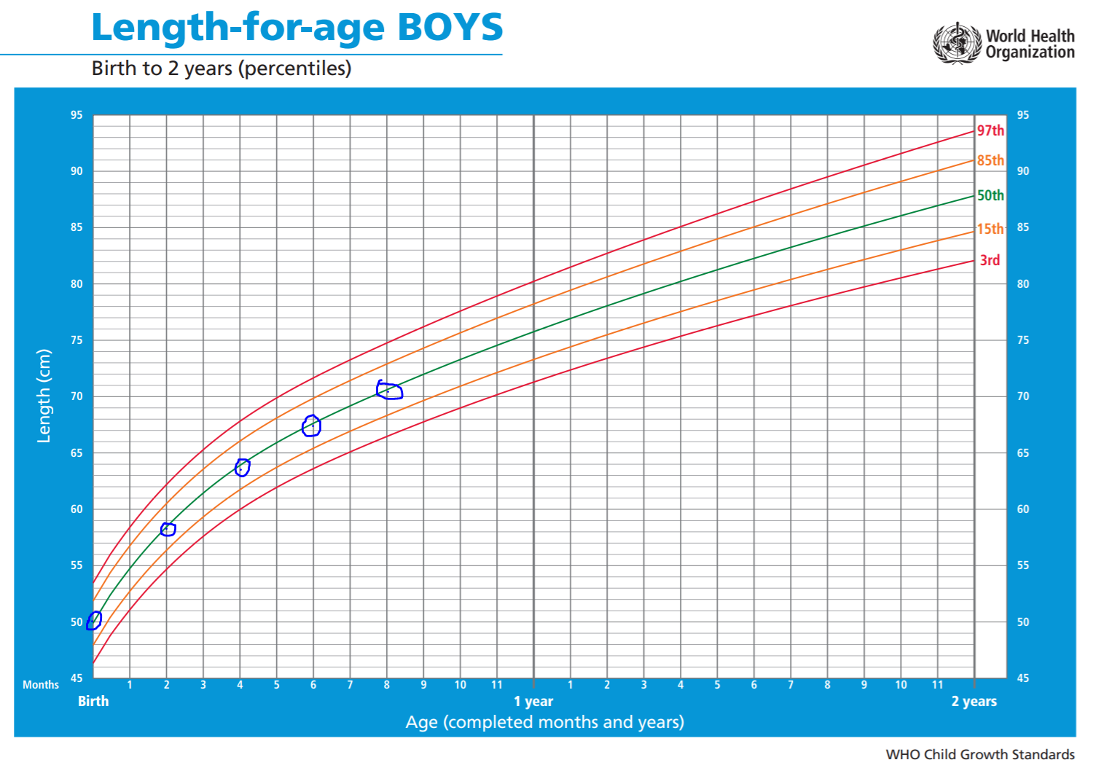
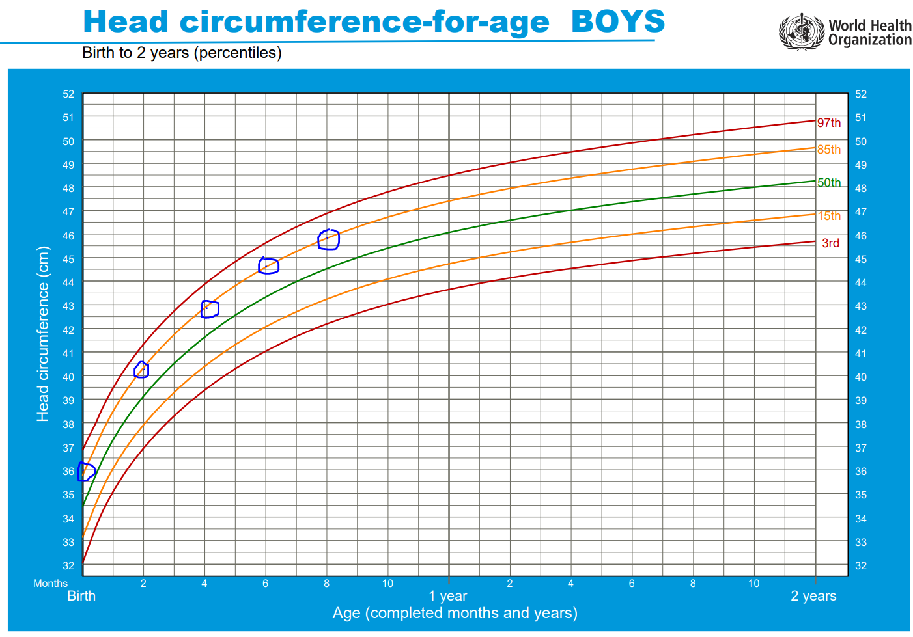
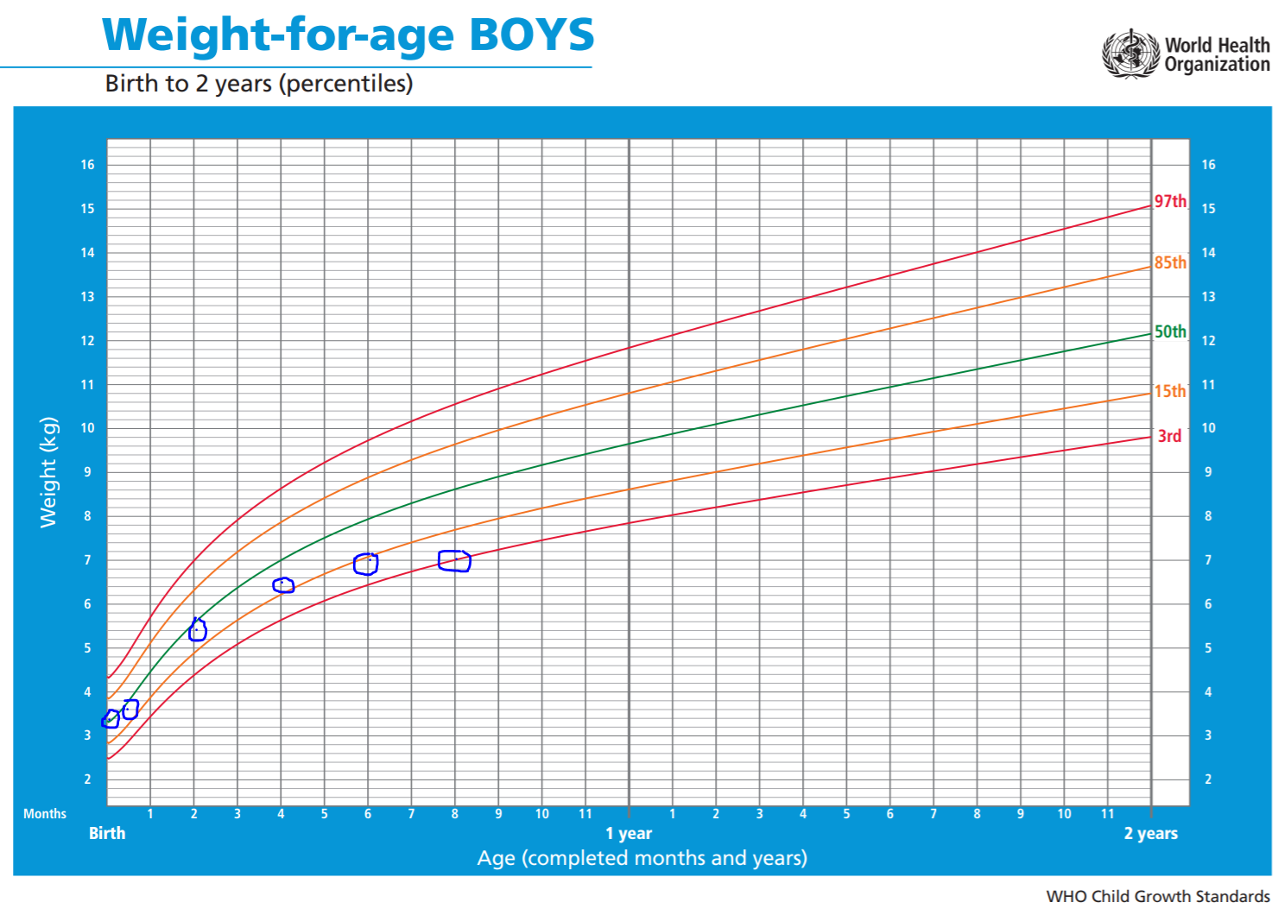
  - Interpret his growth charts. (3 marks)

  - List FOUR diagnoses that could be the reason for his growth charts and give TWO features each you could find out on history.

Diagnosis | Clinical features
1.

2.
1.

2.
1.

2.
1.

2.

He is discharged home. Growing ok again.
Unfortunately, he has a fall off the change table at home onto a carpeted floor but hits his head against the corner of the chest of drawers. He has vomited 3 times since the fall. On examination, he is alert and responsive, but grizzly. There is a haematoma of ~4cm diameter above his left eyebrow. Neurological exam is normal. No other injuries were found.

  - What is your assessment of the severity of his head injury and why? (3 marks)

  - How would you manage his head injury? (4 marks?)

